Create the Folder as name

Capstone_Project

Backend

Frontend

**Backend coding**

1. Eureka Server

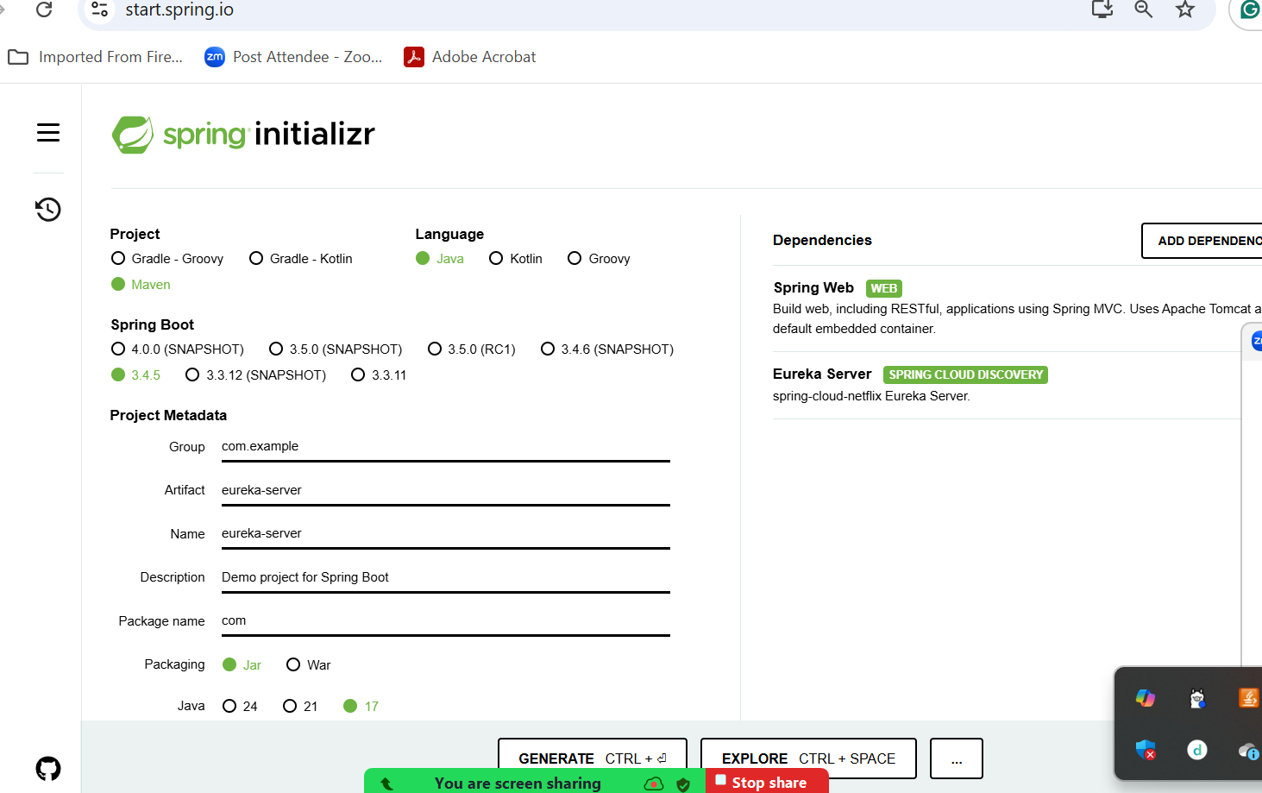

1. Micro Service project

login-app

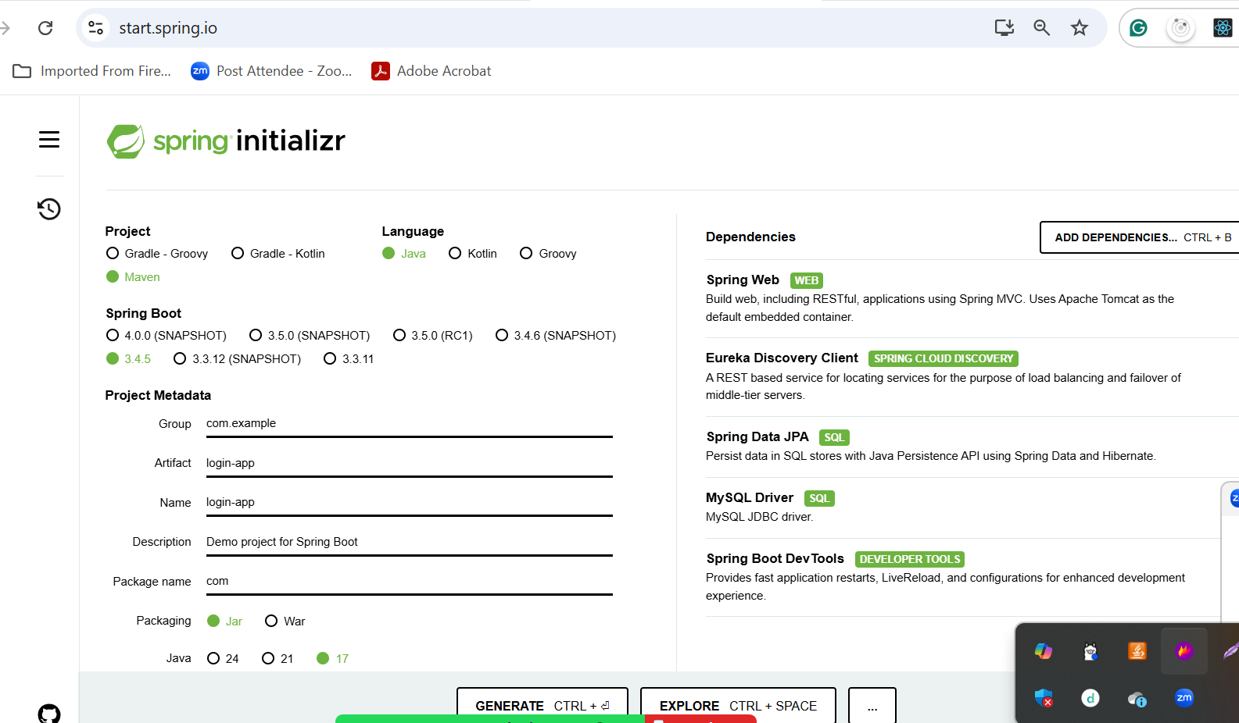

**Front coding**

Inside a frontend folder you need to create the angular project.

Install the angular in local or vm machine

**npm install -g @angular/cli@16.0.1**

**ng version version must be 16.x version**

or

npx @angular/cli@16.0.1 new login-app

ng new login-app

routing -🡪yes

styling 🡪 css

cd login-app

component create

ng g c login

ng g c signup

ng g c admin-dashboard

ng g c customer-dashboard

mode class create

ng g class login

service class create

ng g s login

when front end technologies and backend technologies want to communicate with each other CORS policy make issue

Cross Origin Resource Sharing